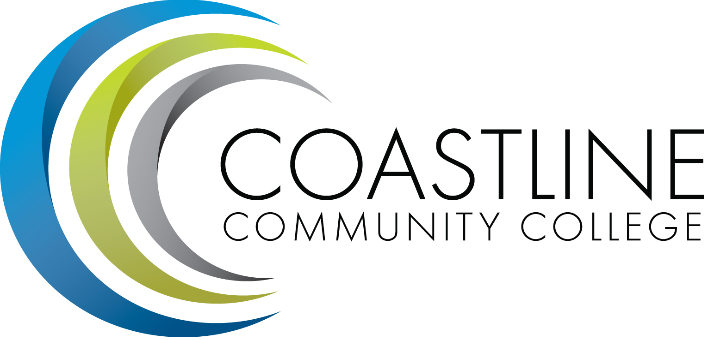

Facilities, Safety and Sustainability Committee Meeting (FSSC) 2017-2018

Agenda
Thursday, December 14, 2017
3:00 p.m. – 5:00 p.m.
College Center – Fourth Floor Conference Room
Committee Mandate: The Facilities, Safety, and Sustainability Committee is mandated to review and plan for Facilities to house sites, programs, and college operations. Safety is to review and recommend procedures and practices to ensure maximum levels of safety and health for all College operations including ADA compliance. The committee will explore and promote avenues of sustainability that the College can use to become a more environmentally responsible campus.

CALL TO ORDER
  - Welcome
  - Adoption of Agenda
  - Approval of Minutes: November 9, 2017

SPECIAL REPORTS
  - Accreditation Self-Study Report Standard IIIB Physical Resources – C. Nguyen, M. Colver, K. McKindley
  - Total Cost of Ownership Presentation – Jerry Marchbank

ACTION ITEMS
  - Follow-up from March 9, 2017 meeting:
    - Install signage that is clearly visible for Parking Permit Dispenser at GGC –
D. Cant. An estimate for pricing of the Parking Permit machine is in process at this time. Should be completed and installed by the end of May (if PORs are processed by District in a timely manner) TO BE COMPLETED BY DECEMBER

  - Follow-up from April 13, 2017 meeting:
    - A task force will be established by the Area Facilitators in order to develop a process and protocol for posting of items on bulletin boards. Follow-up Report will be provided in September.
C. Berry reported that the Area Facilitators met to discuss this issue. The current District Administrative Procedures outlining posting procedures was reviewed. However, the current Procedure as outlined, does not appear to be conducive to Coastline’s needs at this time. After discussion, the Facilitators developed guidelines (to be incorporated into the Policy for Coastline). Cynthia advised that all items to be posted must be prioritized and approved prior to posting. In addition, items to be posted must first be submitted to the Dean’s office or the to the Facilitator’s Office for approval. A lengthy discussion ensued amongst the committee regarding posting of materials on campus sites. The consensus is that a new Policy needs to be written. The Facilitators will create a bulleted list of protocol items and provide an update to this committee in October.
Refer to Item 3.4.2.
  - Follow-up from September 14, 2017 meeting:
    - D. Emerson will follow-up on “inspirational writings” for Le-Jao. Dana discussed plans for development and installation of the writings. D. Thompson suggested obtaining support from the Digital Graphics students for participation in this project. She advised that the vision is to provide wall Accent Designs for Le-Jao. Angela Hollbrook will provide sample artwork from the DGA at the next meeting. ONGOING
    - D. Cant and D. Emerson will follow-up on glass door issue at Le-Jao. Dave reported that Marketing is working on resolving this problem. He will provide a report at next meeting. ONGOING
    - D. Cant will follow-up on Staff parking space problem at Newport Beach Center. Dean to identify and designate Staff Parking spaces. Dave will follow-up on identifying Staff Parking spaces. ONGOING
    - D. Cant will follow-up on parking space problem at Newport Beach Center.

  - Follow-up from November 9, 2017 meeting:
    - D. Cant will research adding key card access for the sliding doors at the Garden Grove facility. Dave will also obtain manual key for the Dean’s office at Newport Beach Center.
    - D. Emerson will provide an update on Posting Guidelines and Policy.
    - M. Colver will research installation of alarms at Le-Jao and Newport Beach to prevent trespassers from entering facilities during off hours.
    - C. Nguyen to provide update on Faculty Access to Facilities.

STANDING REPORTS
  - Area Update Le-Jao Center – J. DeBattista
  - Area Update Newport Beach Center – K. Bledsoe
  - Area Update Garden Grove Center – C. Berry
  - Area Update College Center/Construction Projects Update – D. Cant
  - Campus Safety Report – M. Colver

DISCUSSION ITEMS
  - Wing Plan Facilities Requests – A. Zentner

ANNOUNCEMENTS
6.1 Next Meeting: Thursday, February 8, 2018, 3:00-5:00 p.m. CCC 4th Floor Conference Room

ADJOURNMENT

*Attachment has been emailed.

